Common Structure of SenSys Security Papers
- In the Introduction, they illustrated the method as follows,
- 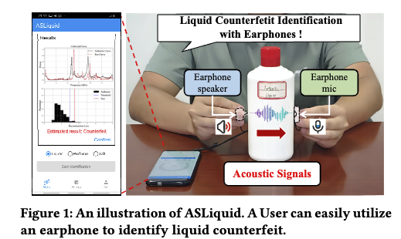
- 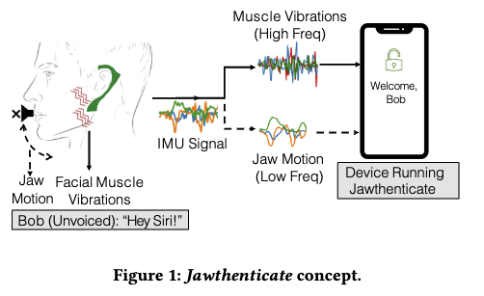
- Talked so much about background and motivation.
- Made one section to discuss potential applications.
- In the Threat Model section, they discussed their methods, real-world use cases, and features in a story form.
- Introduced the system overview in one section and the whole design in another section.
- The system design part took 2.5 pages (they covered the whole system in this section)
- For performance evaluation, they discussed their setup first.
- Discussed performance with a lot of graphs like below:
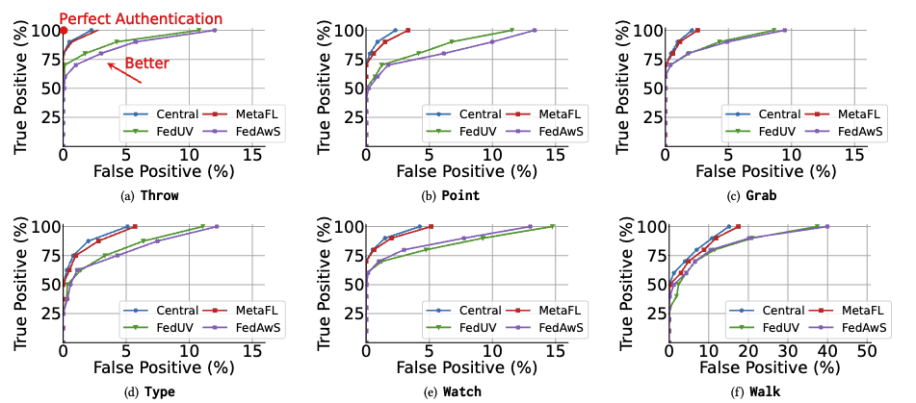
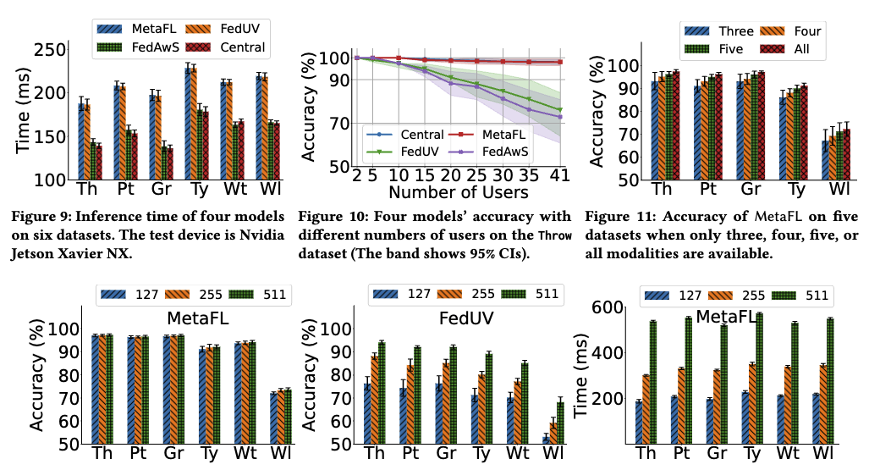
- Did experiments to show the robustness of their approach.
- They also mentioned related work at the end, after the discussion.
- A lot of citations.

